Skewing of the Hoof

The following examples show how many so-called hoof problems were really created by incorrect trimming, and how quickly the hoof will reverse such "problems" when it is listened to and respected.

The hoof can be skewed in many directions. Medial/laterally, anterior/posterior, and rotationally (yaw), and a combination of those. Skewing is most often caused by trimming the heels by looking down at the back of the foot instead of using the sole as a guideline.

Skewing and de-skewing rotationally, Patrick (click on image to view larger version)
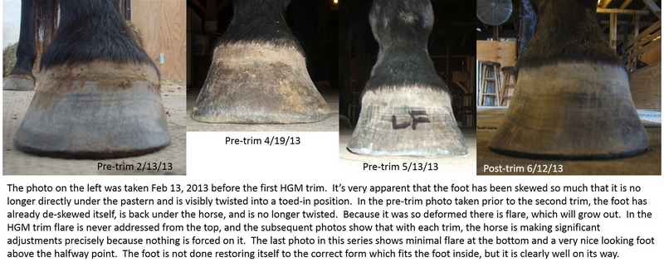

Skewing medial/laterally, Jericho
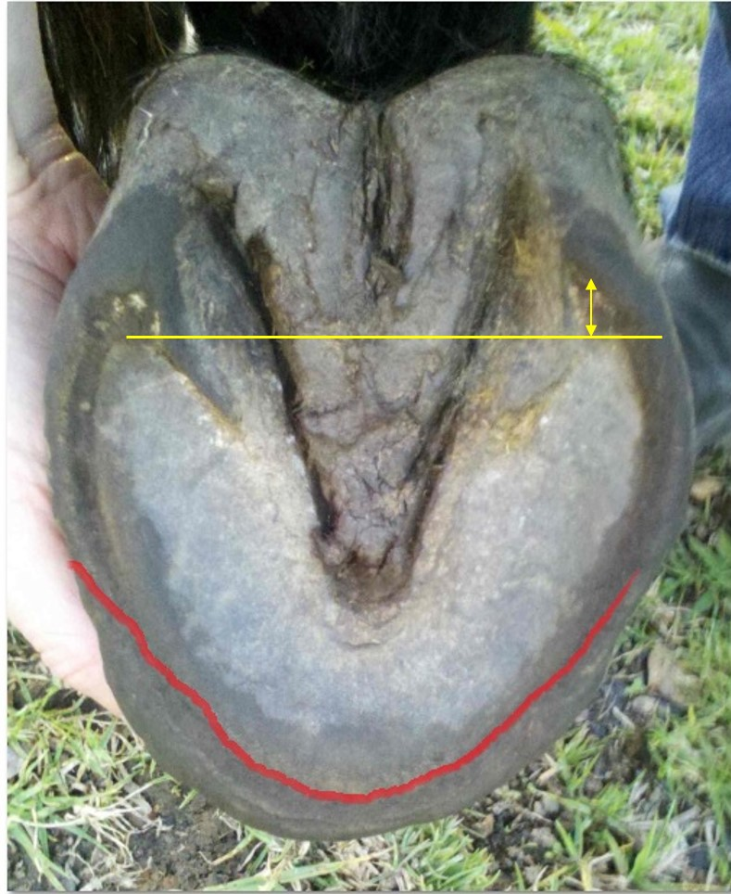 | This photo was taken on June 19, 2013, prior to the horse's first trim using the HGM. The red line is where the owner marked up where she thought the foot should be trimmed. My comments are below:  "RH – This foot is not that great, and I wouldn’t call it better than the LH. It is skewed internally – shown by the heels being very different in position, as well as collateral groove depth. Your markup is correct however and the heels (and coffin bone) will adjust themselves."  The yellow line shows that the uneveness of the heels, and the double arrow shows how uneven they were.  The owner's line is not that even (red) but that is where I confirmed she should do more than just a maintenance bevel.
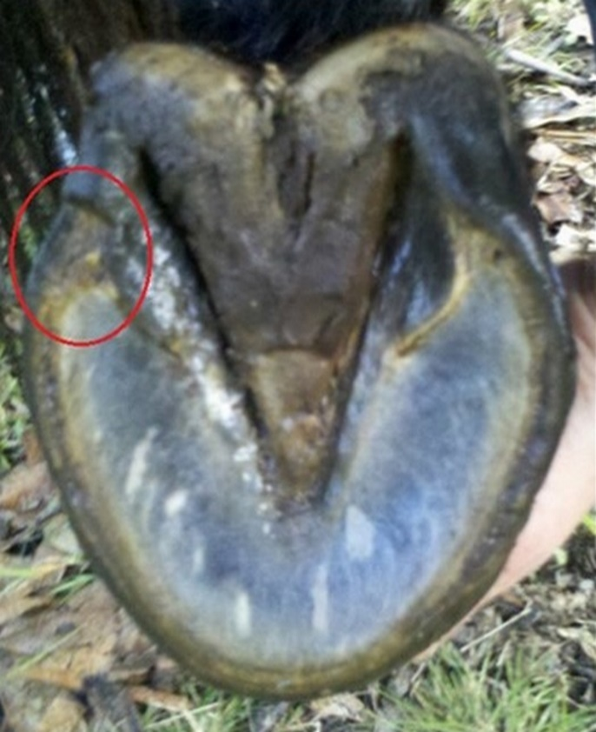 | This photo was sent to me today (July 2, 2013) by an excited owner. She marked the heel area with a red circle to show that only 11 days after the trim the heel has already made an adjustment.

Copyright ©

