Foal Feet
Copyright 2014 by Maureen Tierney (www.barefoottrimming.com)

Not much is really out there about foal feet, hopefuly this article, and the related case study, will be of help to many of you.
I occasionally receive the question, "When should I start trimming my foal's feet?" My answer is always right away. Many people think 3 months, or even 6 months! That is way too late. Why? Because foal feet start changing as soon as a foal is born.
In the womb, the feet do not experience any sort of pressure. As soon as the foal stands and nurses, that all changes. Below is a photo of my foal Oz's foot, a week after birth. I took the photo while he was lying down as it was simpler than trying to wrestle with him.
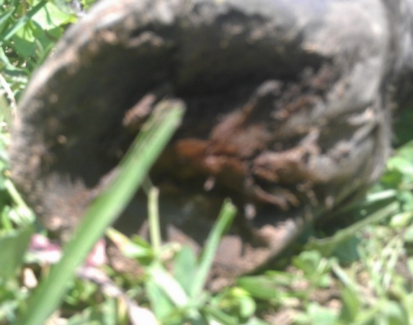 | This photo is of my colt Oz's right front foot. It was taken when he was 7 days old. Let me say right away that Oz was outside 10-12 hours a day at that time, in a herd of 11 horses on 20 acres. Since he was an orphan and needed frequent feeding, he was confined at night until he was about two and half weeks old. If he had been stalled full time or just out in a small area, I would have looked at his feet much sooner.  You can see that there is a lot of concavity, the frog takes up a lot of room, and there is no "heel purchase" or "heel buttress". Which I believe is normal - see the mustang foot, left.  The large flat area commonly called heel purchase is, in my opinion, something that was "created" by man so that shoes would have a nice flat area on which to sit. Natural hoofs, and hoofs that become healthy enough to self-trim the heels, do not have them.  As luck would have it, I was contacted about the feet of a foal born only 3 days after Oz. Oz is a Thoroughbred colt, the other foal is also colt, a breeding stock Paint (a Paint with no spots). When I saw the photos of the other foal, Keeper, I was surprised. The heels were already very long and the foal was younger than Oz. It is worth noting that Keeper was overdue, the mare foaling at 354 days.
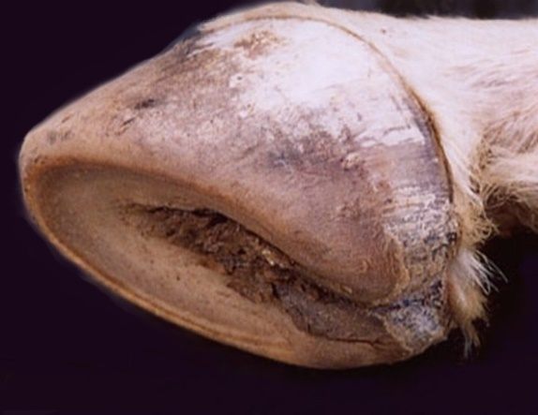
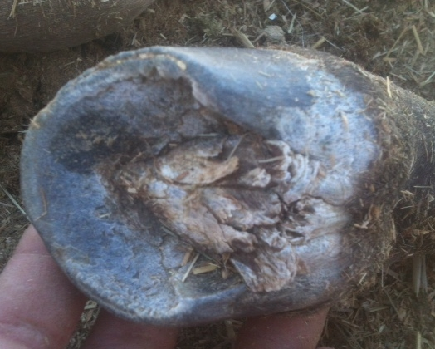 | To the left is Keeper's RF foot taken less than a week after foaling. Notice how much heel he has. This heel clearly grew in utero! Like Oz, there is a lot of concavity, and the frogs are very similar.  What should be clear from this photo, is that foal foot trimming can - and most often should - start just after birth.  Many of the clients I've talked to over the years, tell me that their horse has had bad feet since it was born. I used to seriously doubt that, and believed it was bad hoof care somewhere along the way. Viewing Keeper's foot, it's easy to see that many horses probably do have hoof problems from birth.  Sadly, correct trimming is not that common, so foals that don't get truly correct trimming are really at a disadvantage.
I'm not going to put all the photos here in the article - they will be in the case study here. This article is just to point out some things people don't usually consider, as well as how to trim a foal foot, and why some people think their foal is developing a club foot or feet.
I have to say I have never seen a newborn who has a club foot, but I would bet that the club foot is very apparent when the foal is born. What is considered to be a "clubby" foot, is actually, I believe, the tiny foal foot growing out.
I have however seen a foal whose mother had a laminitic episode while in foal and the foal's feet showed signs of laminitis also. The mare's laminitis was fairly severe and was caused by a change in hay to one with very high sugar. I am not suggesting the foal had laminitis because the mare did, more likely because he too was sensitive to sugar.
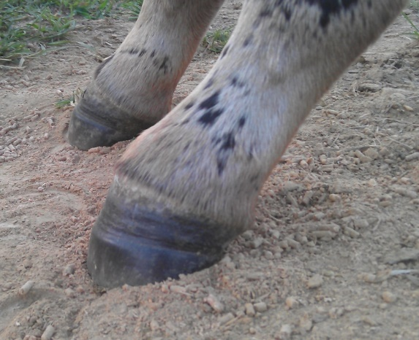 | To the left is a pre-trim lateral shot of Oz's left front. Photos are really important to help us actually SEE the foot, so look at your foal's feet, but also take photos - you'll be surprised by how much more you see.  When I saw this photo I was a little taken aback. But I didn't panic. I just trimmed the foot, beveling from 8-4 and not very steeply. Post trim sole shot is below left.
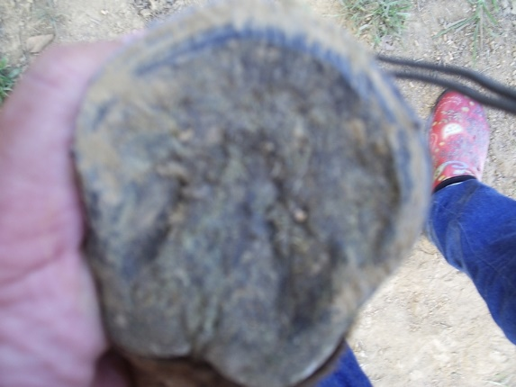 | Oz lives out 24/7 on hard clay, varied terrain, with hills and ponds (photos are in the case study). The main hill is 1/4 mile long and the elevation rises 100 feet. So he has close to optimal conditions. His feet are very hard!  I didn't touch the heels as they are at sole level. I beveled the rest of the foot to sole level, and that really is how foal feet should be trimmed. Heels and hoof wall both at sole level.  Oz had very little to take off. I didn't take pre-trim photos because it's hard to hold a camera with one hand, and hold a foal foot still with the other hand. You can see the photo is somewhat blurry.
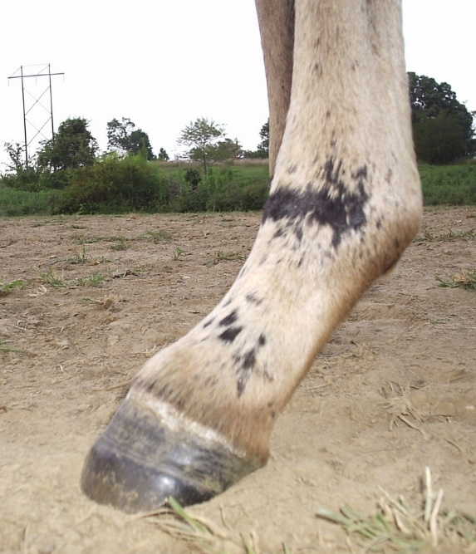 | Post trim, the foot looks very different and the hoof/pastern angle is better. It's really the toe that is the issue, not the heels.  So why did it look clubby? Because the bottom of the hoof is what is left of his tiny baby foot! That little tiny hoof can't get larger once it's there, it has to grow out. Because it's so much smaller than the new foot, it looks odd. But it's perfectly normal.  The pre-trim photos were taken Aug 1 and the post trim photos on Aug 2. On Aug 2nd Oz was exactly 10 weeks old. And you can see by the distinct line, that he has already almost grown out an entire new hoof capsule.
So how often should you trim? As often as necessary. Anytime the hoof wall is above sole level, take it back down. Foal feet grow and change quickly. As the foal gets heavier, the coffin bone continues to grow and the back of the foot develops. It's important that the frog get good ground pressure so that both it and the digital cushion develop as nature intended.
Below is a comparison of Oz's left front on July 19th (left) and the same foot on Aug 2 (right). That's 14 days. A combination of trimming any excess wall, movement, and weight gain all contributed to the frog, bar, and sole changes.
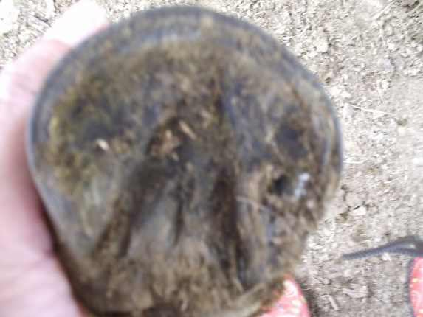
As you can see, there were big changes in that 14 days! The frog is bigger, the bars are lower, and the frog is not buried in sole anymore.
Don't just look at the foot from the lateral view. It can be deceptive. The sole tells the true story and that's what you have to look at.
Keeper's sole shots are below and show just how much a foot can change in a short time - and how necessary correct trimming is. If his owner hadn't trimmed him - correctly - his feet would just have continued to contract. Left to right: June 3 (first trim), June 11, July 20. It should be noted that he is out in a relatively small enclosure, but his owner also takes the mare out every day for a walk of several miles, letting the foal run free - so that he gets a good amount of exercise.
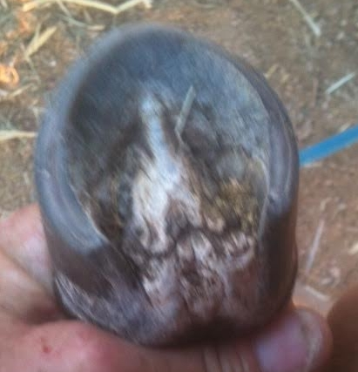 | 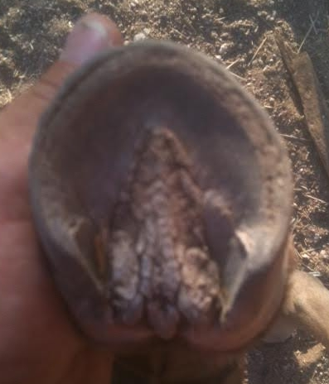 | 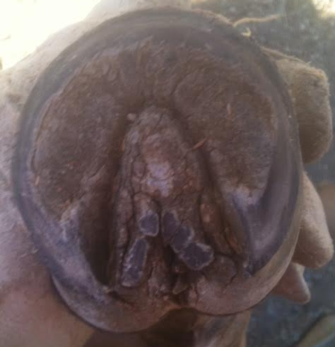
Good hoofcare starts at birth, please don't wait 3 months or more to start trimming. And remember, we should never dictate to the foot by trimming to an ideal. You can see that Oz and Keeper have very different feet. They are different breeds, live in different areas, and have different diets. Each will have the feet his DNA and environment create.
We should always respect the foot and, with foals (and minis), just take everything down to sole level.
Don't forget to check back and view more changes at Foal Feet Case Stud

